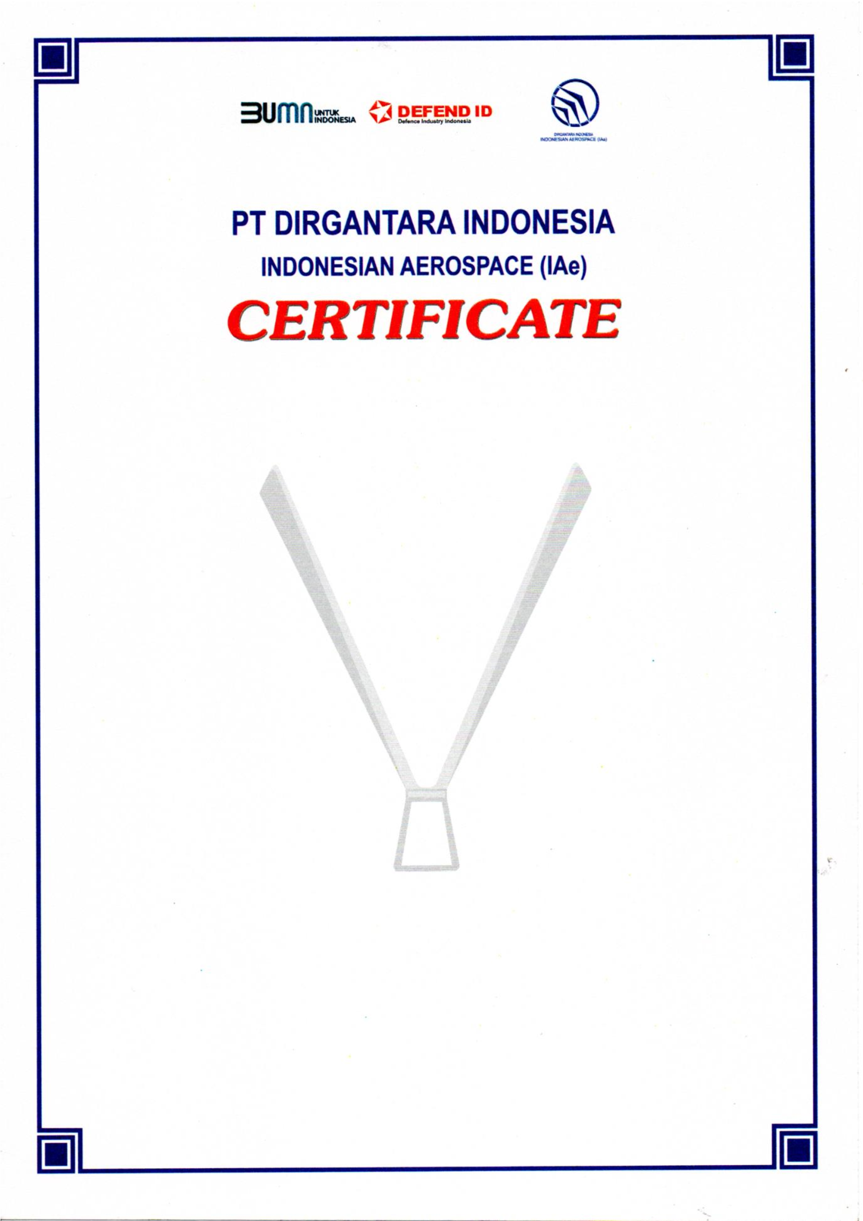

NO: 0017/037.08/HD0000/01/2022

This is to certify that

Adi Sudarsono / 140860

has completed the training of

BASIC AIRWORTHINESS
The training covered the following subjects:
Requirement Development, Initial Sizing, Aircraft Configuration,
Aerodynamic Configuration, Performance, Stability & Control, And Wind Tunnel Test

Conducted from
January 17 to 21, 2022

Bandung, January 11 , 2022
Head of Human Capital Division
Muhammad Luqman

